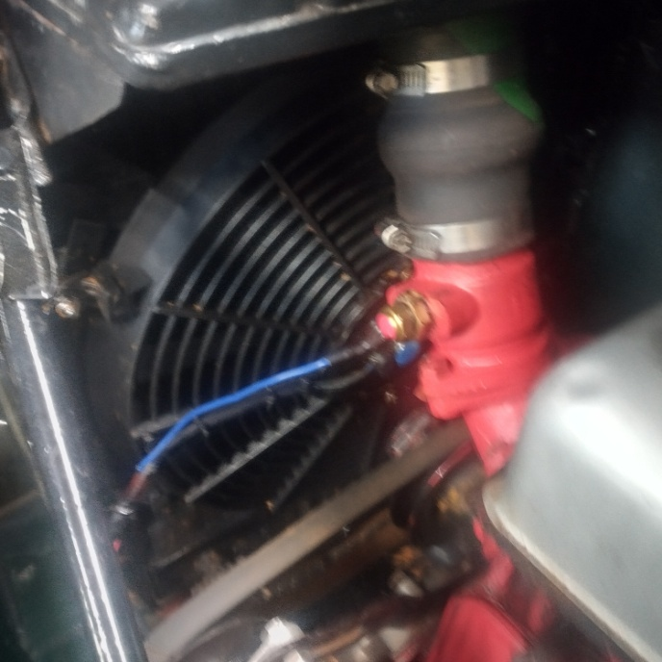
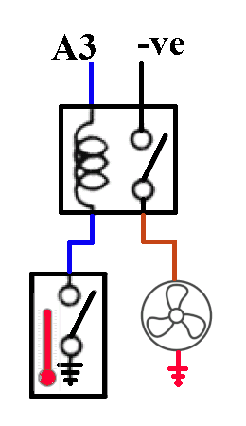
My MG TD had always run hot, and sometimes wouldn't start again once it had stopped.
I was satisfied that, on the balance of probabilities, I had the distributor problem under control, and having tried everything else, I looked again at the cooling system, and blamed the fan. Then, on one of the recent road trips, first one fan blade broke, and then, shortly after, its other half. Although it made a mighty bang when it failed, I couldn't find any damage inside the engine compartment. I could have replaced the fanblade, but since I was blaming the fan as inadequate it wouldn't have solved my problem.
I sourced a 14inch 80W electric fan from the web. I took off what was left of the old fan, which left plenty of room between the engine and the radiator. The new electric fan fitted perfectly, and I fixed it directly onto the radiator using brackets made from 1/2inch brass strip.
The fan came with a relay and a thermostat. The thermostat was a switch which closed when the temperature reached the operating temperature, connecting its one terminal to ground. It closed at about 190ᵒ F and stayed closed until it fell to 160ᵒ F, measured in a pan on the cooker, using Margaret's cooking thermometer. From her reaction, I was able to infer that knowing the operating temperature of my thermostat was not a priority for her.
The car had never had a radiator bypass thermostat since it came to me, and I had blanked off the bypass. So I took off the thermostat housing and turned it around so that it faced left, not right as it had done. I took off the elbow, and drilled and tapped the port to 1/2 inch BSP to take the new thermostat. I sawed off the redundant Y-branch pipe and made a straight connection from the radiator bottom hose to the water pump. Also I took the opportunity to stop some of the leaks by tightening some of the hose clamps.
I connected the thermostat in series with the relay coil, and the other side of the coil to the A3 terminal on the fusebox, so that whenever the ignition was on the coil would be energized, and when the thermostat reached operating temperature it would close and activate the relay. (The thermostat is the only component on the car which relies on earth return through the engine block or chassis, but it is a pretty good connection with unmeasurably low resistance to earth, and anyway the coil has a resistance of about 100Ω so a bit of resistance in the return path would be immaterial). I connected one side of the relay switch to -ve supply, and the other side to the fan. The earthy side of the fan was connected to +ve battery terminal. I might reassign one of the dashpanel lights to be in parallel with the fan, to give visual indication when it's on.
On a fast idle, the car took about 15 minutes to reach 195ᵒ F (90ᵒ C) when the thermostat pulled in and the fan turned on. The temperature began to fall immediately, even in Sydney's 35ᵒ ambient. It took about another 15 minutes to stabilise at about 175ᵒ F (80ᵒ C). With the old mechanical fan driven by the belt, it would have been boiling after about 20 minutes, so I hope and expect that my problem is now solved. Of course, this is based on stationary idle, not driving conditions, so I might still be disappointed. But the omens are good.
And the omens do seem to have been reliable: after a 1 1/2 hour drive through traffic in the morning peak the temperature had stabilised at 185ᵒ F (85ᵒ C), and after a further 2 hour drive, mostly on motorways, it was still 180ᵒ F (82ᵒ C)

