MGB Restoration Part 2

With the car now on its wheels, it was time to find all those parts which had been restored previously or bought. A list which showed the order at which parts are fitted would have been helpful, e.g. the door cards are put on after the chrome strips are fitted and the door mirrors are bolted on.

Researching different aspects of the rebuild, the fitting of the windscreen frame base rubber was voted as one of the hardest of tasks, and yes, it was. I don’t know why I didn’t use silicone spray in the track before fitting.

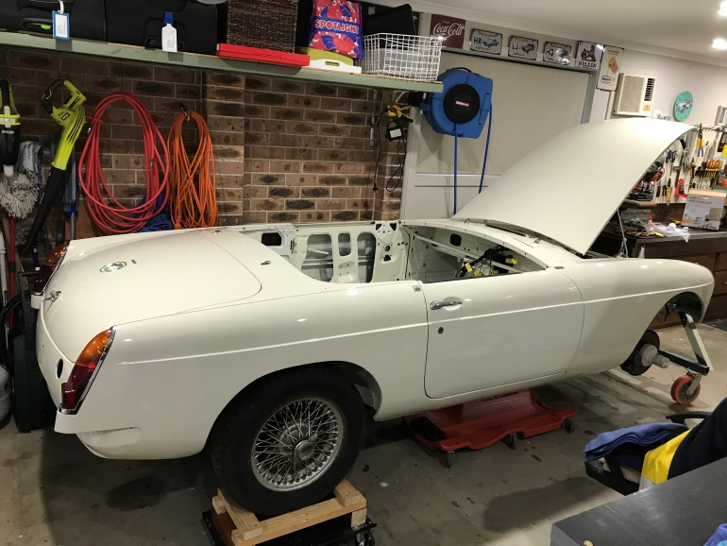 I was looking forward to fitting the interior panels. The original colour was red, so the replacements also needed to be red.

This was when the project started to look more like a car, especially when new chrome was fitted.

The dash was pulled from storage. This had been painted before putting away and I could remember not being happy with the finished outcome. OCD kicked in, so it was sanded back and repainted. This happened several times until I was happy with the wrinkled finish. Gauges were fitted with LED lamps and the dash was set in place.

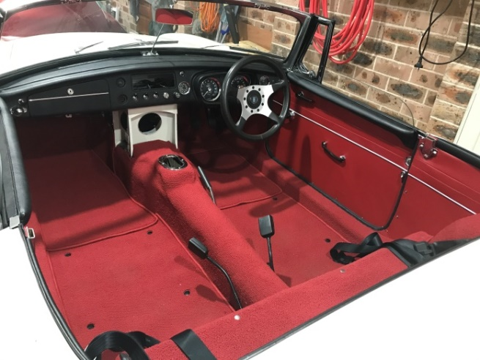Sound deadening and carpet (14 pieces in all) were bought and fitted to the car. To put nice clean holes in the right positions in the carpet, a small bladed screwdriver was pushed from the underside, then appropriate sized metal tubes were heated, pushed into the carpet to form the holes.

Mechanical items such as steering and brakes. were installed

The car has now been set up with a negative earth. This will assist with the installation of any new electronics, such as distributor and radio. Most other electrical components have been fitted with extra fuses. The 1963 MGB had only two fuses and one of those was for the horn. The car now has nine suitably rated fuses.

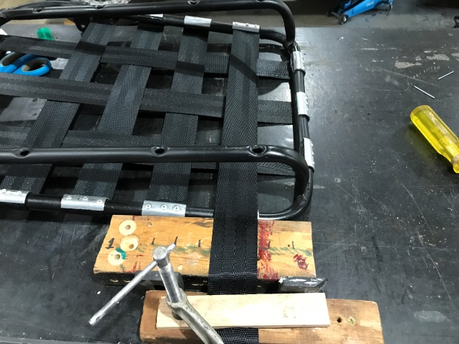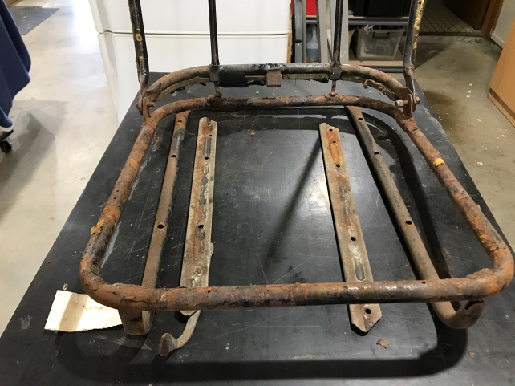The seats were in fairly sad condition. I had another pair which were not much better.

The best seat frames were cleaned, welded back together and painted. The original seat support was a rubber diaphragm which research showed tended to fail quickly. I therefore fitted new webbing which was stretched into place. A couple of different stretching methods were tried, till I settled on the pictured version.

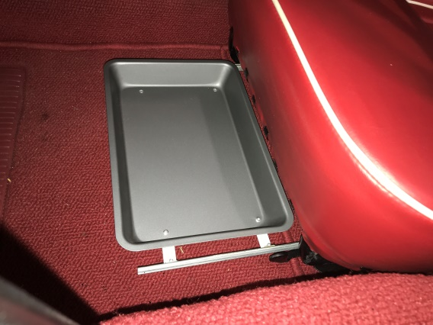The MGB has a lack of simple, easily accessible storage for one’s phone or wallet, so while I was playing with the seats, I fitted a sliding shelf (a slice tray from the kitchen), that runs under the driver’s seat.

The rebuilt fames were then fitted with new backboards, base and back foams.

Upholstered seat covers were made by Mark Wells of “Hogs, Rods and Restos” at Robinson. He’s done a nice job.

The petrol tank was dragged out from its hiding spot, cleaned inside and out, repainted and fitted to the car. A new fuel pump was fitted along with a filter before the pump.

The time had come to start the engine rebuild. After some procrastination, I decided to have the engine professionally rebuilt. This was one of my better decisions. I spoke to Bob Rowntree Automotive at Thirlmere. He told me to take the stripped engine to his machinists who would measure the block and other components.

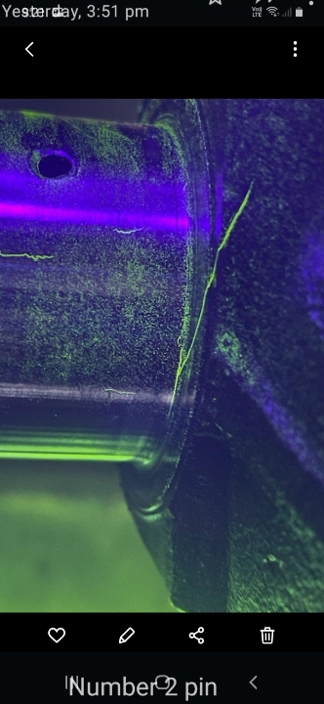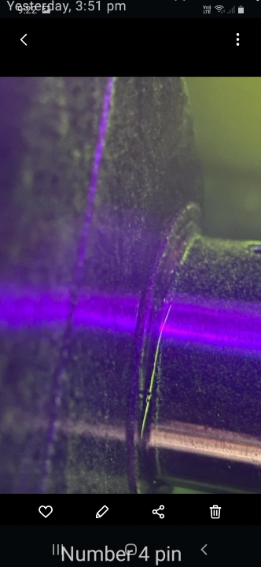All measurements came up to spec, but only just. The bore and bearings were already 20thou oversize, so the easy decision was made to machine to the next size. Before machining, the crankshaft was crack tested and this showed up two cracks.

Problem: This motor was the original three bearing motor for the car and I wanted to keep it. So the hunt was on for another crank. These are fairly rare. After a couple of months and a few false starts, I found one (and only one) which was brand new. Expensive!

It appeared that during a previous rebuild, a mixture of different valves had been installed. The head also received some attention after machining with hardened valve seats, new valves, and new valve springs.

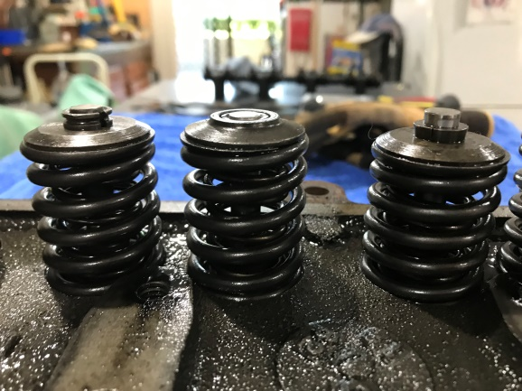

On completion of all machining, the motor was reassembled with new internals. It was then installed with the transmission attached.

The carburettors also had some attention. They were fully stripped, cleaned and bushes were replaced. A new standard exhaust was also fitted.

The radiator was sent off to be cleaned, flushed, pressure tested and painted. Not much left now. The petrol tank was filled and flushed a few times, together with the fuel pump and piping up to the engine bay.

The car was then placed on a trailer and towed back to Bob, who gave the motor its first start. He also ran in the new cam bearings, set the timing and tuned the carburettors.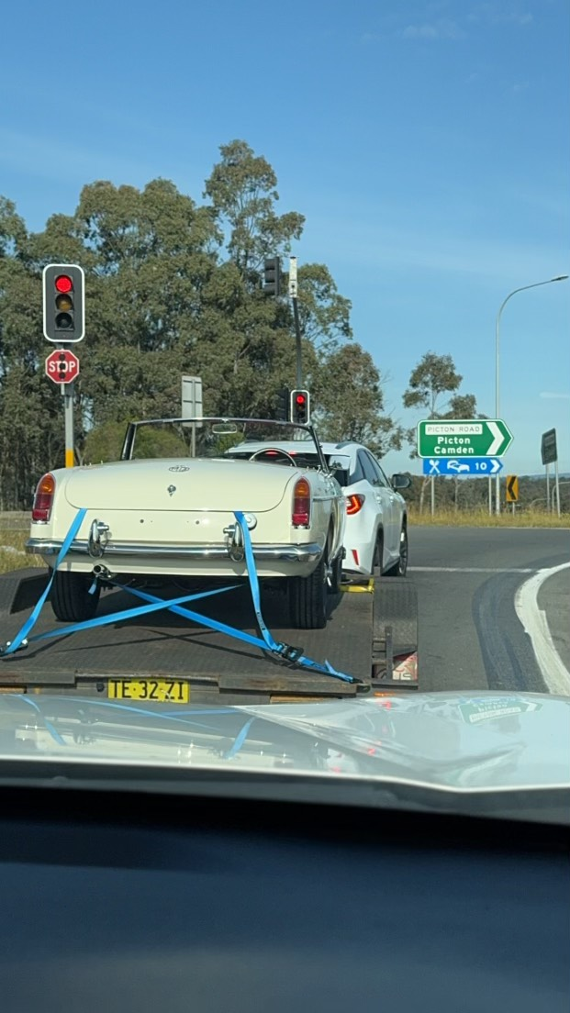 As expected Bob gave me some homework.

The starter motor was occasionally sticking, which was disappointing as I had stripped and cleaned the Bendix prior to fitting to the motor. A new Hi Torque starter fixed that problem.

The charge light was staying on, however the generator was testing well. I concluded that the problem was with the Lucas regulator. On swapping with the aftermarket unit that came with car, that problem was solved.

Another challenge was the choke not locking when fully extended.

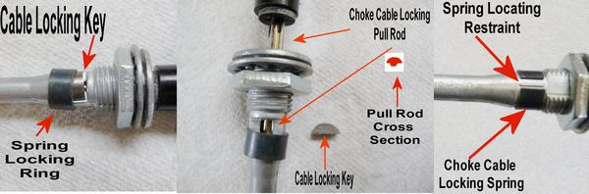One of the quickest and easiest sources of information on the MGB was the internet. Often I would check sites such as MGB Experience, and search whatever I wanted to know. Over the years, someone had already asked the same question. A fine example was when I checked the choke cable locking mechanism and got this image above. The original locking key is sometimes plastic which breaks quickly but mine was metal and had worn a groove. A small weld filled the groove and was then filled flat.

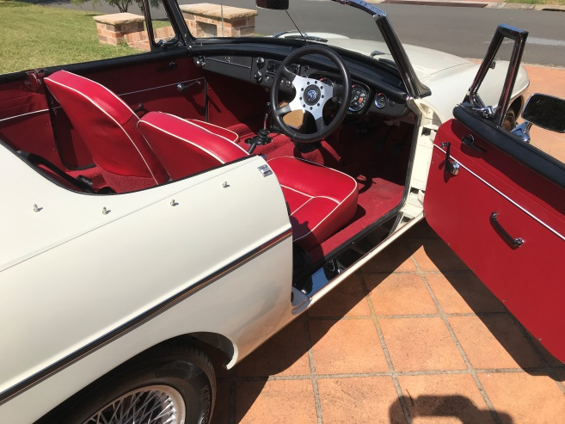After 22 ½ years, the car is now on the road and going on short reliability runs to sort out the gremlins. There is a saying, ‘a car restoration is never finished’. I learned a lot about MGBs and am sure that some things could have been done differently or better. There have been many frustrations, but I have enjoyed the long journey.

