MGB RESTORATION - PART 1

I always wanted to restore a car. Over the years I worked on my own daily transports as needed, but I wanted a project. Why an MGB? Over the years I had friends who owned MGBs, and I worked with people who had MGBs as their daily drive. I can recall back in the mid-60s going to a family friend’s place where the owner had a B. Although I don’t remember the car, I do remember the removable white hard top on a stand in the garage.

So my restoration project was to be an MGB or a LJ Torana GTR, which was my wife’s preference. Somehow, I won and an MGB it was to be. But not any MGB. I wanted an Australian assembled Mk1.

So, in February 2002 I found what I was after. On the good side, a 1963 car with matching numbers and fairly original. On the bad side, several shades of white to cover the accidents and rust. The car drove well, had plenty of torque and was smooth ride on the road. The car was to be restored to original, but not concourse condition.

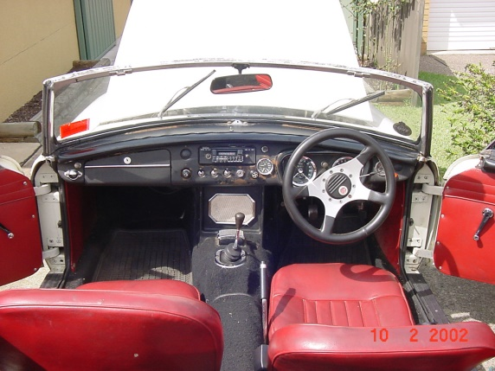A months’ worth of Rego was used to get acquainted and show the car off, then it was pulled it apart. The B was loved by the neighbors. With only a hotdog in the exhaust it could easily set off their car alarms.

The time came for the car to be stripped down. It was placed onto a rotisserie to aid with transport and to increase access all round. The rotisserie was home made using 2 engine stands joined at the bottom and had larger solid wheels which made moving around the garage easy. The body was to be sand blasted, so everything had to come off. Many parts as they were taken off were restored, tagged and stored away.

Dismantling showed extent of the rust, and sandblasting showed the thickness of the bog used to cover the dents and holes. Once sand blasted, POR15 was used on the good panels and those that needed work were given a spray of rattle can undercoat.

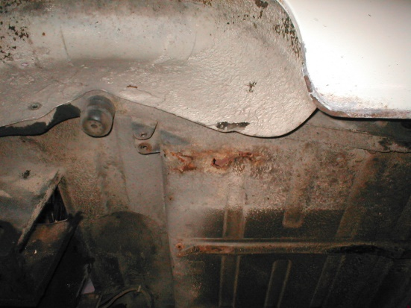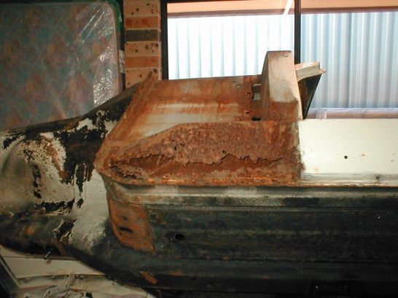 Sills Boot

Rust claimed many panels, including the sill panels on both sides. Fortunately, the inner sill panels were good as were both floor pans which had been already replaced by the previous owner. The boot floor and both inner and outer rear guard on the driver’s side, also needed to be replaced due to rust. The rear beaver panel was replaced as it was severely dented and filled with bog up to 12mm thick in places and still way out of shape. The front guard on the driver’s side had also suffered badly from rust on the lower section.

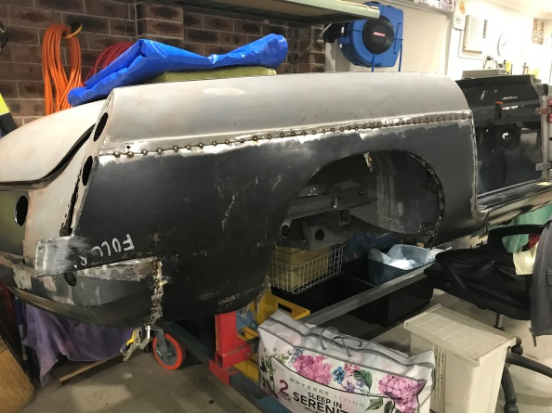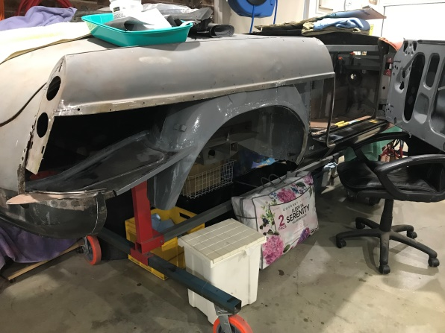

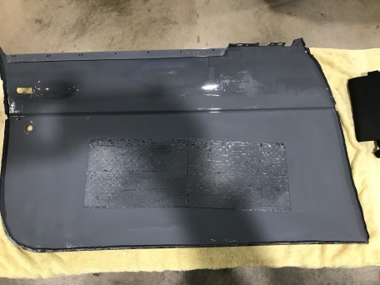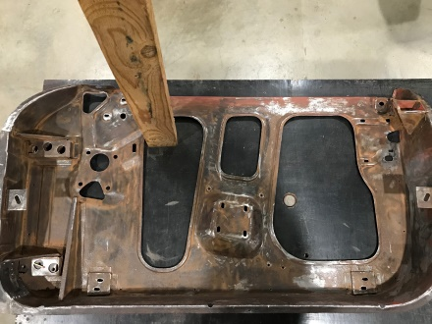The passenger side door was twice the weight as normal due to the amount of filler used to fill the huge dent in the middle and the rust on the bottom of the door. Mk1 doors are not very common. Ebay 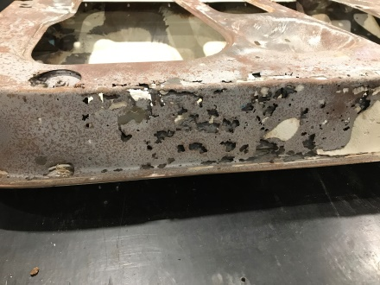got me a Mk1 door with a good frame but bad outer skin. A Mk2 door provided a good outer skin. So it was out with the grinder and a homemade tool to lift the inside door skin lip, separate the panels, clean up the good pieces and join them together. Once done I needed to modify the door skin around the lock area to except the Mk1 lock barrel.

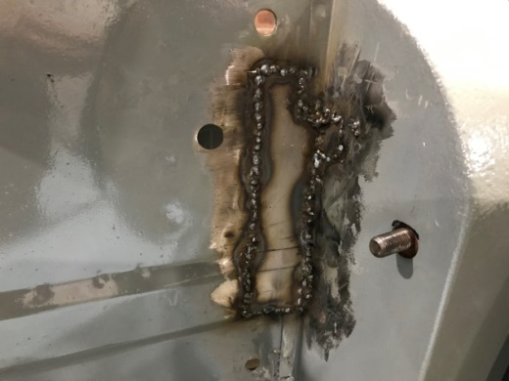

Another area for panel repair was on the front inner guards. The MGB door hinges are fixed with 4 countersunk screws easily seen, and a hidden nut at the back which could only be accessed when removing the guard, or what’s called the splash plate. A previous repairer was not aware of the splash plate so had used the gas axe to cut four slots from inside to remove the nut.

With most of the sheet metal work done, the body was sent out to be prepared for paint. Then off to the paint shop for fresh paint in the original colour of Nuburg White.

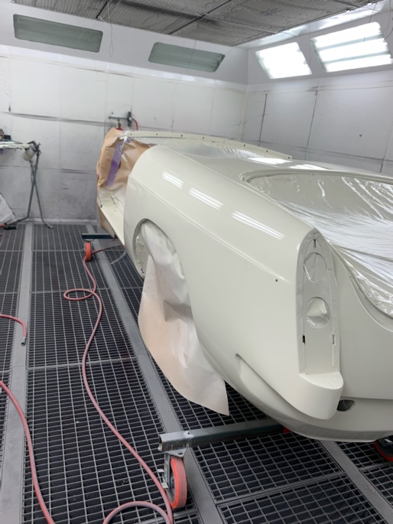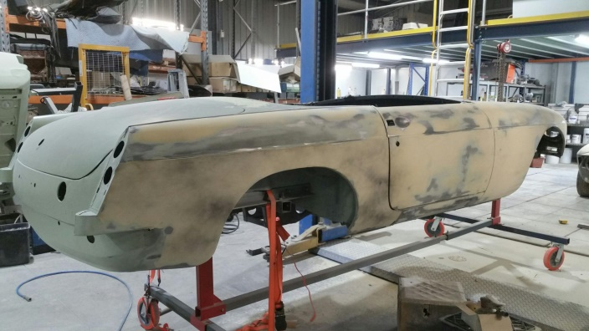

With the paint work completed, the car was back home and the fun part of putting it back together was started.

While still on the rotisserie, much of the work underneath was completed, this included new brake lines, fuel line and wiring harness.

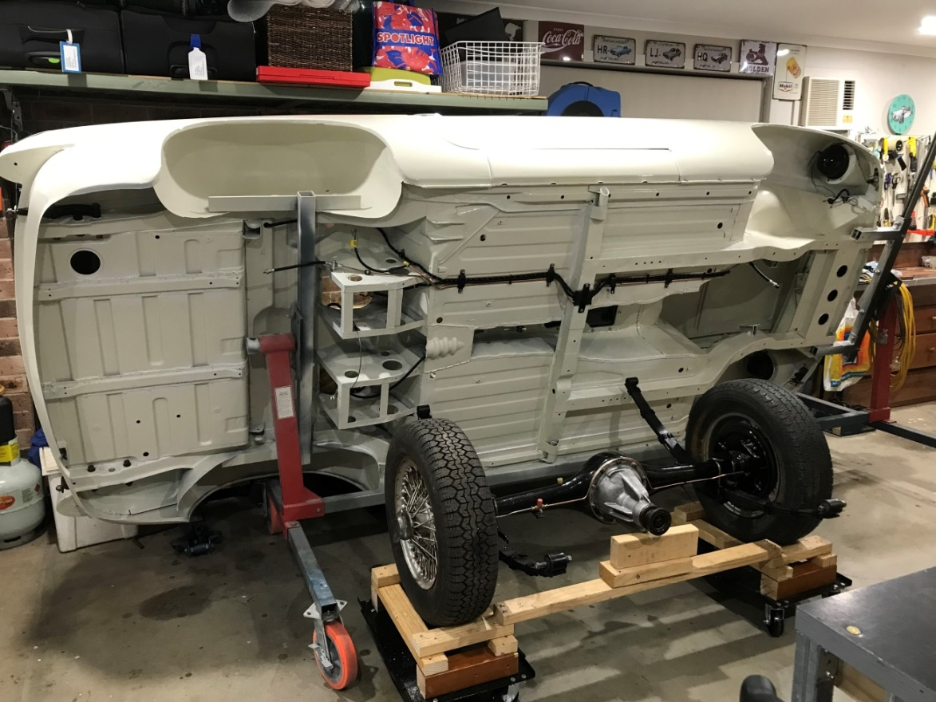

Next the body was to put on its wheels. The front cross member was restored early on with all new parts, along with the rear axle. Covid was in full swing at the time and new rear springs were not available so I had the old ones rebuilt. Once on its wheels the car was placed on a set of dollies which again made it easy to move around the garage.

Part 2 to follow