Axle wear on 1952 TD

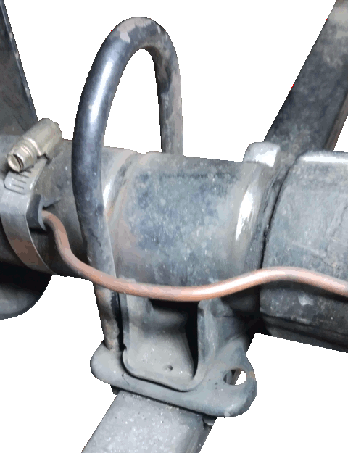While driving home from the 2024 Natmeet in Tamworth, I drove through one of the notorious New England potholes, and the arm came off the splined shaft on the rear right shock absorber. Again. It made no discernable difference to handling, but it did make a distressing clunk as the link arm hit some part of the bodywork every time it deflected. All the links should be parallel, so there should be no sideways force to cause the separation, and as far as I could see it all was good. Nevertheless, even industrial grade Loctite had failed to prevent the separation. The fix I chose was to put a couple of spotwelds on the splined shaft. Real conservators don’t like this, but better men than me have done the same, and I could see no other solution. But while I was removing the damper to enable this, I found a different problem.

The picture shows the axle. One of the U-bolts locating the axle to the springs has been partially withdrawn, and the other removed entirely, showing the deep grooves worn into the soft cast iron axle casting by the U-bolts. You can see by the bright metal that the wear has been continuing, even though the U-bolts were now completely tight and there was no detectable movement of the axle on the springs, and you can see how in another 100 miles or so it would have worn right through the casing, and the wheel, complete with brakes, backing plate, bearing, oil seal and half shaft would have come off. Well, perhaps not: it would have been held on by the handbrake cable and the hydraulic pipe.

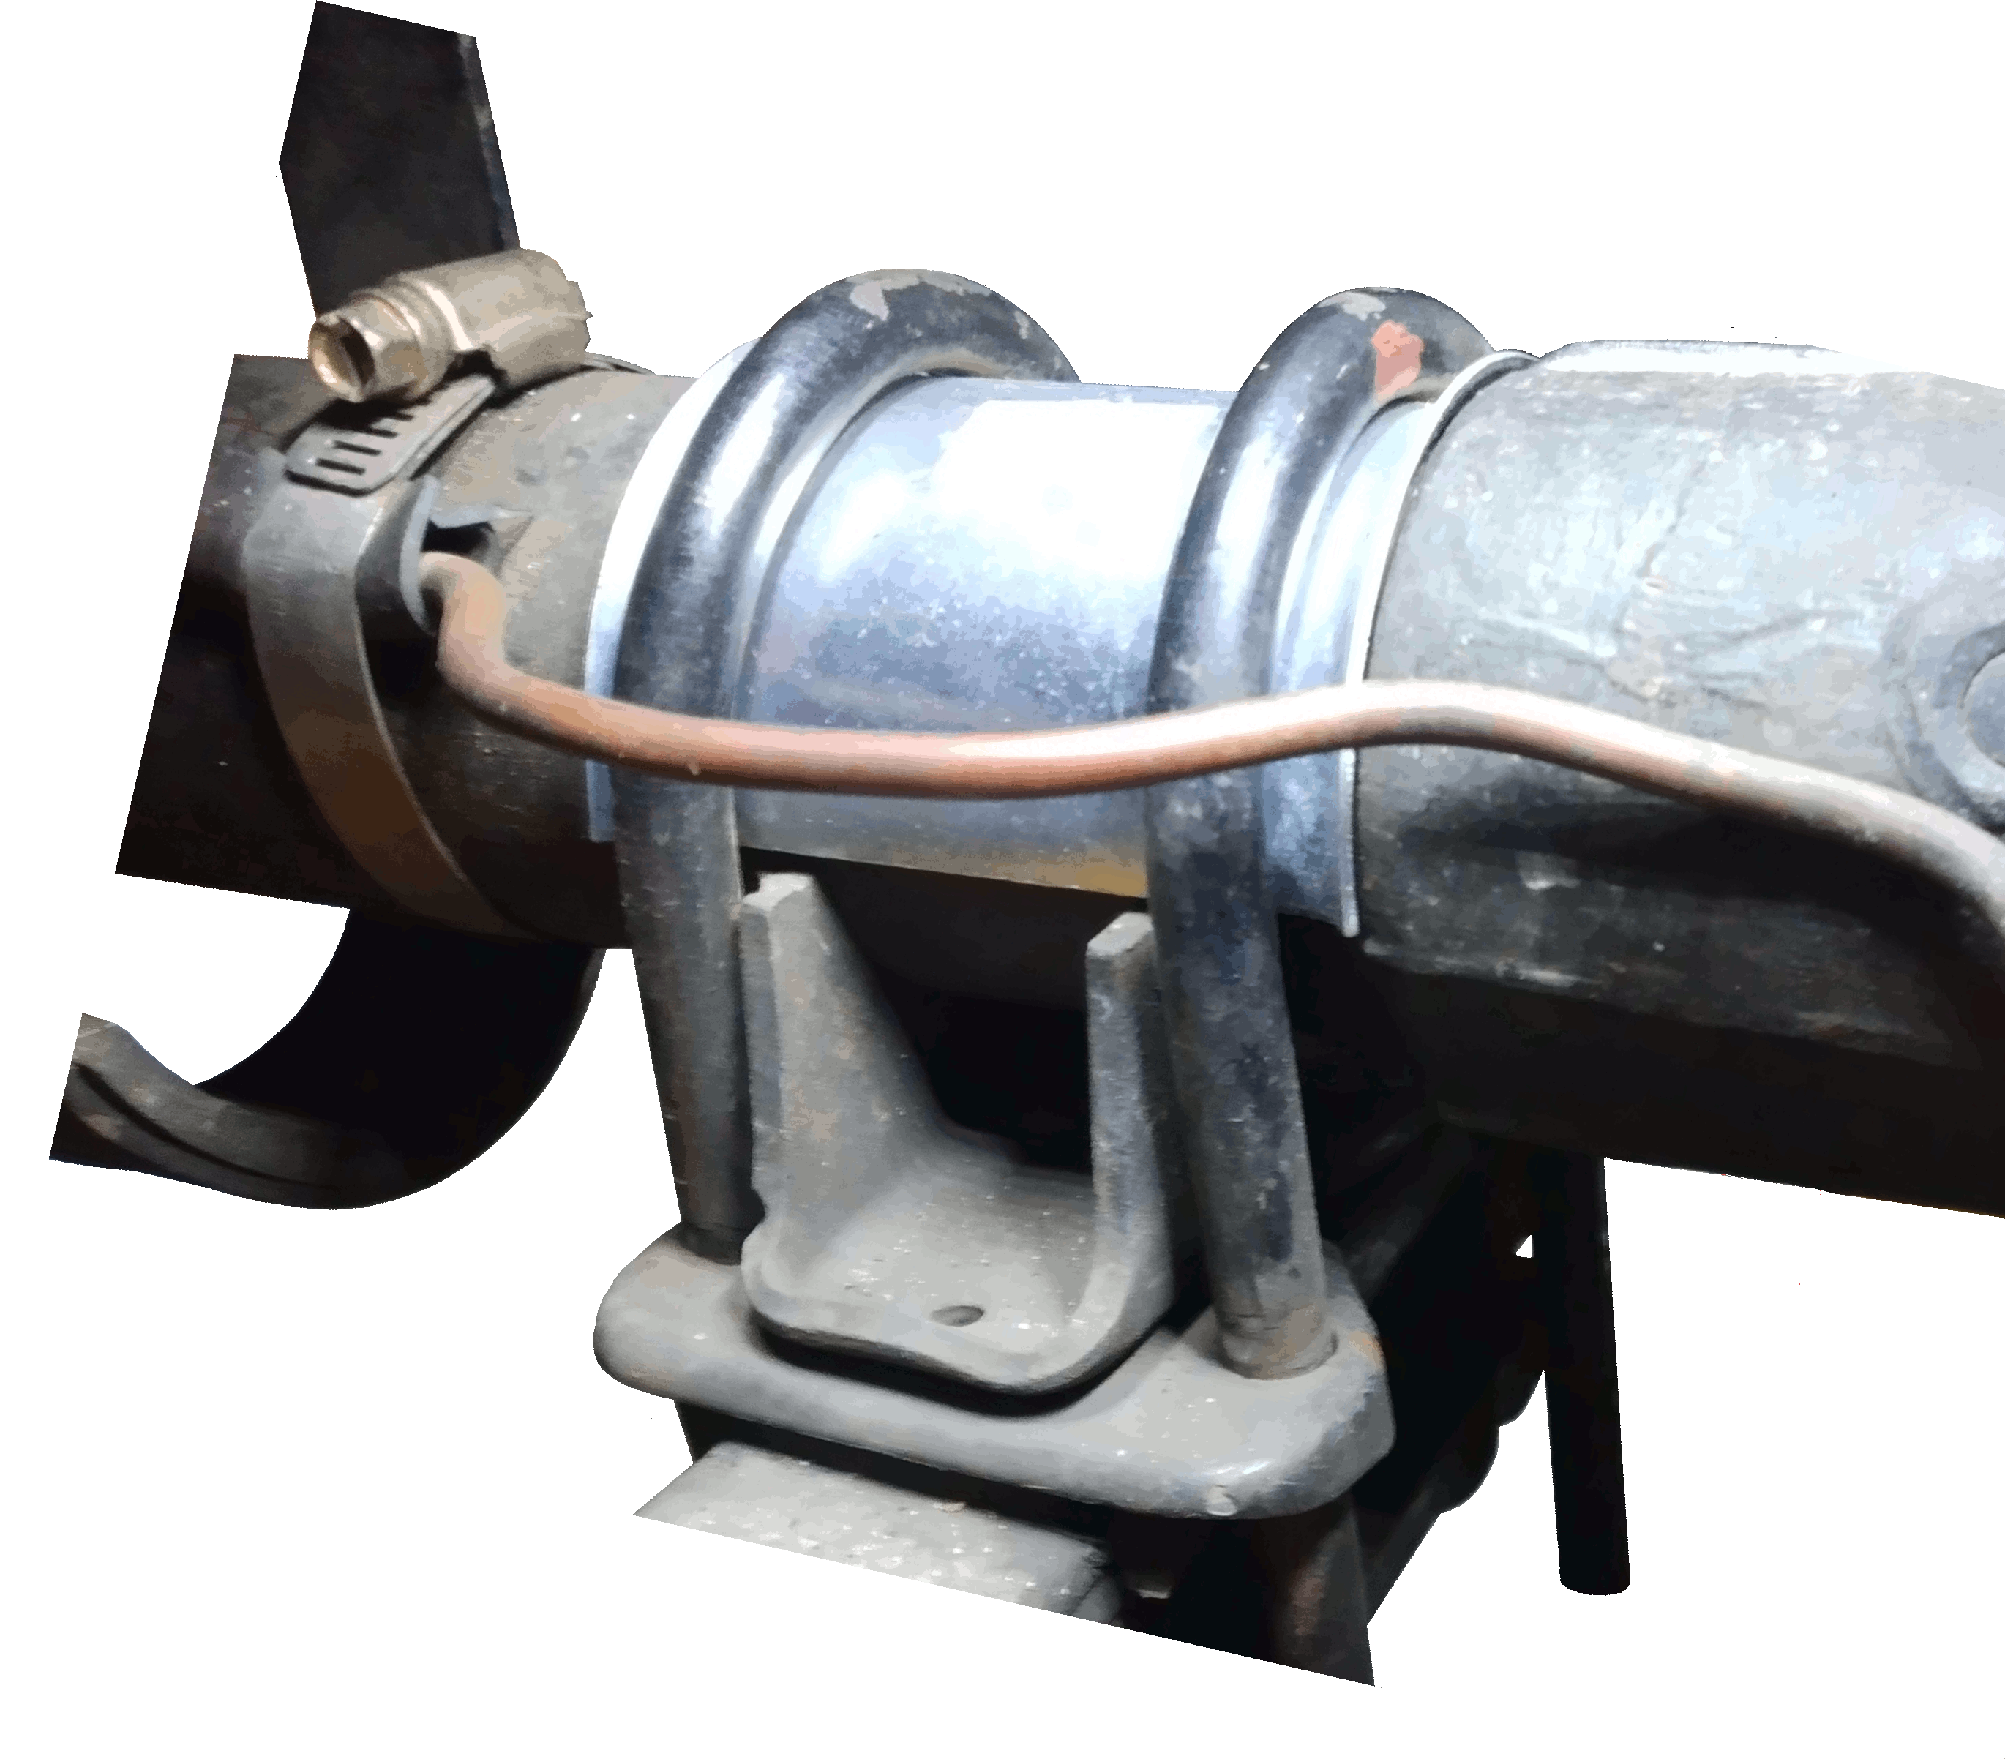The fix is a small plate shaped to fit over the axle and around the U-bolts. This aftermarket part wasn’t available in 1952, when the car was built, because no-one thought the axle would wear so much. And I don’t believe it was available when I began the resuscitation of the car forty years or so ago, because if it had been, I’m sure I would have used it. But from the fact that it is available now, you can infer that mine is not the only car to suffer from this problem. You can possibly also infer that everyone else, including all TD and TFs, all Y-Types, and, I don’t know, all MGAs knew about it already and made the fix long ago, and that I am the last to realise it, and that I need not have written this note.